Instructions on creating Midwest Internet Dial-Up and Mail Settings in Windows Vista:

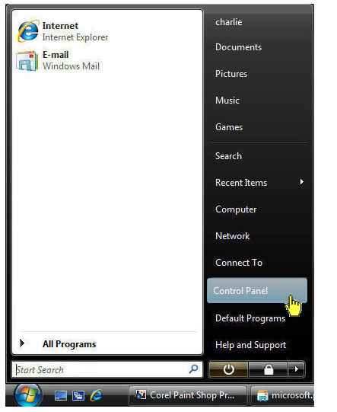

Click on the start button : 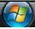 and then click on the “Control Panel” option.

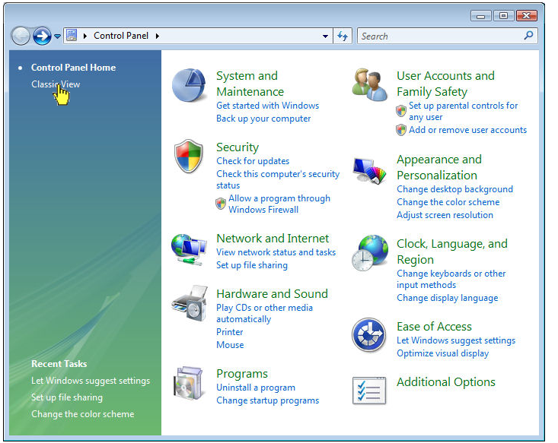
Click “Classic View” at the upper left.
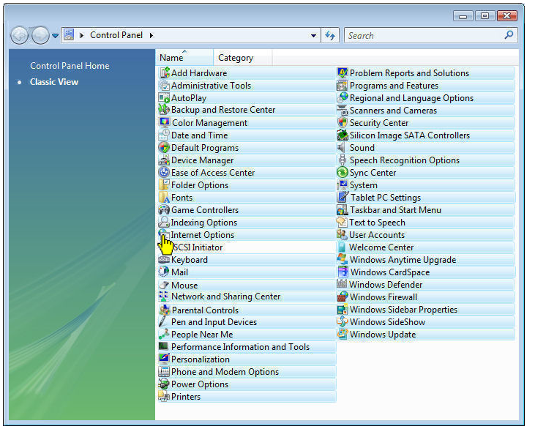

The Control Panel options will change to the “Classic View”. From the list on the right, double-click on “Internet Options.”

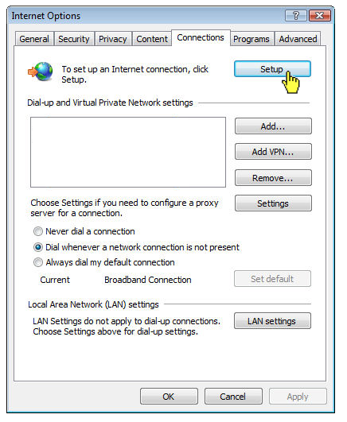

Click on the fifth tab labeled “Connections.” Click on the “Setup” button at the top right.

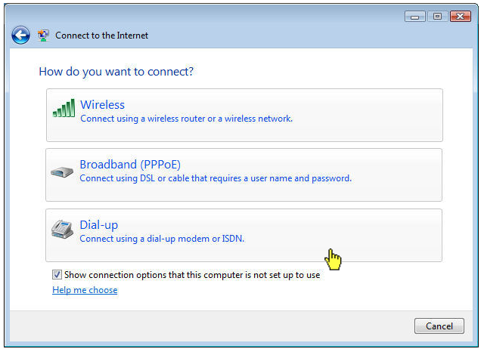

You will be presented with at least two options. Click on “Dial-Up.”

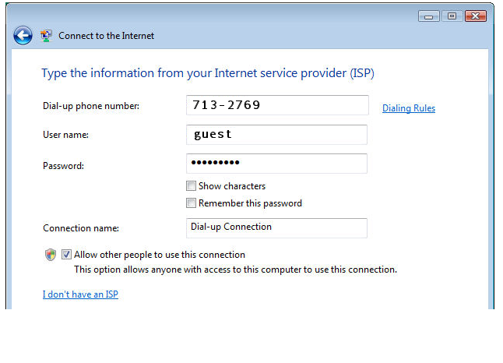
A form will now appear before you. Enter the following information:

Dial-Up Number: Look up the Midwest Internet number for the city nearest you under the Products and Services section. Enter the seven-digit number for your location listed below:

Cities Served:
Indianapolis and surrounding suburbs (317): 713-2769
Anderson and Muncie (765): 442-0000
Crawfordsville (765): 368-5405
Frankfort (765): 670-3000
Kokomo (765): 450-0001
Lafayette (765): 237-5575
Lebanon (765): 484-0205
Marion (765): 682-1000
Martinsville (765): 343-5062
Shelbyville (317): 395-5062

Username and Password: Enter the word “guest” in both of these fields. Be sure to type in lower case letters.

Add a checkmark next to “Remember This Password.”

Click on “Connect” on the lower right.

The next screen will show that your computer is going to test the connection. Click “Skip.”

Next screen may state that the test connection failed. Ignore this statement and click on “Setup Connection Anyway.”

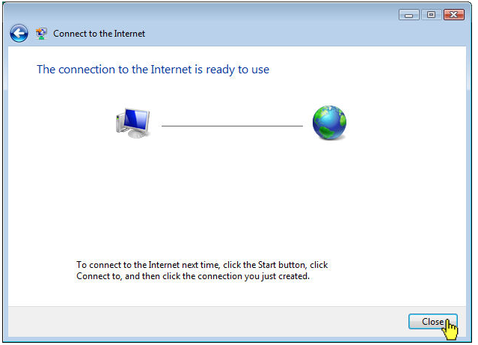

Final screen will say the connection is created and the setup process is finished. Click “Close.”

Open Internet Explorer and connect. You will automatically go to our website.

Click on “Sign Up Today”, located at the upper right corner of our website.

Follow the instructions, create your account and make a payment.

After that, exit out of Internet Explorer and disconnect.

Open Internet Explorer. At the dialup connection, type in your new MW.net username and password. Connect, and you’re all set.

Be sure to write down your Midwest Internet username and password on a sheet of paper in case you forget it.

